Template of IJO Original Article

All submissions must be typed in Times New Roman with 10.5 pt, 1.5 spaced front, and 2 cm margins all around

Title XXXXXXXXXXX
Running title: XXXXXXXXXX
Author¹, Author², Author^{1,3}
¹Authors’ unit should arrange from small unit to country
²Department of Ophthalmology, the Third Affiliated Hospital of Jinzhou Medical University, Jinzhou 121000, Liaoning Province, China
³Department of Ophthalmology, Research Institute of Ophthalmology, Giza, Cairo 12511, Egypt
Correspondence to: Author. Authors’ unit. email

Abstract (An informative, structured abstract of no more than 400 words should accompany each manuscript)
AIM: Only the purpose should be included, and begin with “To do” sentence pattern.
METHODS: The materials, techniques, instruments, equipments and study designs, outcome measurements, and the experimental procedures as well as statistical methods should be included.
RESULTS: The observed and experimental results, including data, effects, outcomes, etc. should be included. The results should be concise and statistical significance should be presented as appropriate.
CONCLUSION: Conclusion should be justified by the study findings and the value of the findings should be specific in relation to its application.
Review articles require non-structured abstract.
KEYWORDS: XXX; XXX; XXX (3 to 5 key words)

(Main text)
INTRODUCTION (FIRST CLASS SUBJECT)
XXXXXXXXXXXXXXXXXXXXXXXXXXXXXXXXXXXXXXXXXXXXXXXXXXXXXXX^{[1]}. XXXXXXXXXXXXXXXXXXXX^{[2-3]}.

PARTICIPANTS/MATERIALS AND METHODS (FIRST CLASS SUBJECT)
Ethical Approval (Second Class Subject)
XXXXXXXXXXXXXXXXXXXXXXXXXXXXXXXXXXXXXXXXXXXXXXXXXXX. XXXXXXXXXXXXXXXXXXX.
[Note: For all manuscripts reporting data from studies involving human participants or animals, a formal review and approval, or formal review and waiver by an appropriate institutional review board or ethics committee is required, and should be described in the Methods section. For investigators who do not have a formal ethics review committee (institutional or regional), the principles outlined in the Declaration of Helsinki (2008) must be followed.
Clinical Trial Registry: When publishing clinical studies, IJO aims to comply with the Recommendations of International Committee of Medical Journal Editors (ICMJE) on trials registration. Therefore, authors are requested to register the clinical trial presented in the manuscript in a public trials’ registry, and include the trial registration number in the Methods section.]
Third class subject
XXXXXXXXXXXXXXXXXXXXXXXXXXXXXXXXXXXXXXXXXXXXXXXXXXX. XXXXXXXXXXXXXXXXXXX.
Statistical Analysis (Second Class Subject)
XXXXXXXXXXXXXXXXXXXXXXXXXXXXXXXXXXXXXXXXXXXXXXXXXXXXXX. XXXXXXXXXXX.

RESULTS (FIRST CLASS SUBJECT)
XXXXXXXXXXXXXXXXXXXXXXXXXXXXXXXXXXXXXXXXXXXXXXXXXXXXXX. XXXXXXXXXXX.
Table 1 Flow cytometry showing the cells characteristics %
Groups | Blank | CD45 | CD90
hUCMSCs group | 0.6 | 0.2 | 88.2
hDPSCs group | 0.2 | 0.4 | 89.0
hPDLSCs group | 1.7 | 1.4 | 94.6

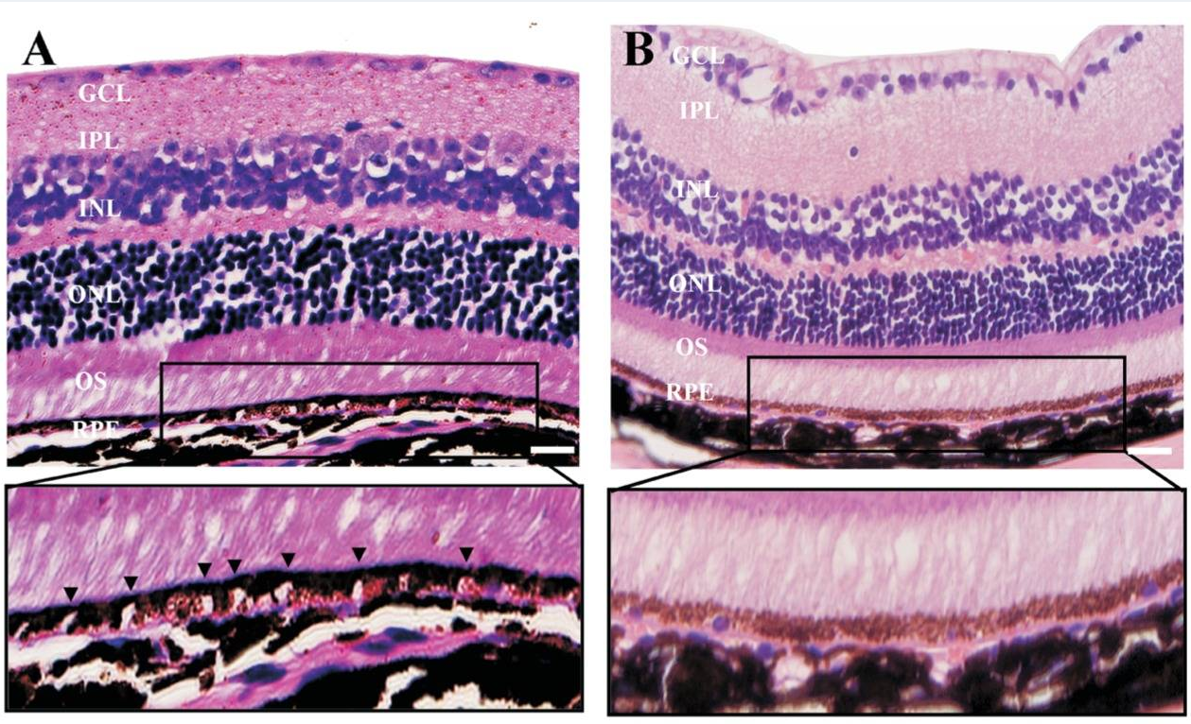
Figure 1 XXXXXXXXXXX A: XXXXXXX; B: XXXXXX. Scale bar: XX. (The figure legend should first have a conclusive legend and then the separated A, B, C, D legend.)
A scale bar should be added to the micrograph.
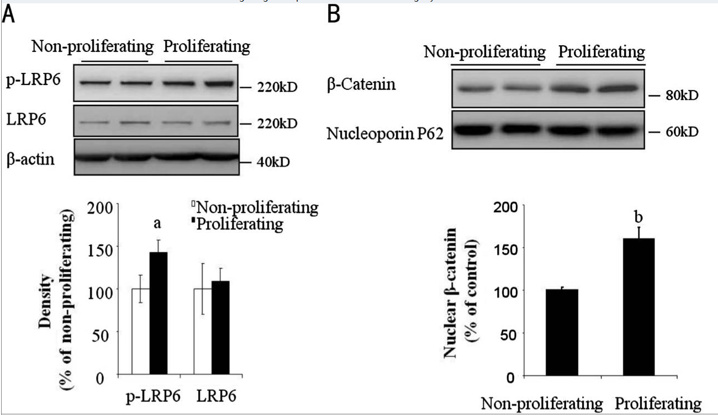
Figure 2 XXXXXXXXXXX A: XXXXXXX; B: XXXXXX.

DISCUSSION
XXXXXXXXXXXXXXXXXXXXXXXXXXXXXXXXXXXXXXXXXXXXXXXXXXXXXX^{[5-9]}. XXXXXXXXXXX.

ACKNOWLEDGEMENTS
Authors’ Contributions: XXXX
Data Availability Statement: XXXXX
Foundation(s): Supported by XXXXX (No. XXXX).
Conflicts of Interest: e.g. Wang H, None; Barteselli G, None.

REFERENCES
1 (Journal article) Authors' surnames and initials. Article title. Abbreviated name of journal Year;vol(issue No.):inclusive pages.
e.g. Yuan A, Ahmad BU, Xu D, Singh RP, Kaiser PK, Martin DF, Sears JE, Schachat AP, Ehlers JP. Comparison of intravitreal ranibizumab and bevacizumab for the treatment of macular edema secondary to retinal vein occlusion. Int J Ophthalmol 2014;7(1):86-91.
2 (Entire book) Authors’ surnames and initials. Book Title. Edition number (if it is the second edition or above). State (or Country) of publisher: Publisher’s name; copyright year.
e.g. Naumann GOH, Holbach L, Kruse FE. Applied Pathology for Ophthalmic Microsurgeons. Germany:Springer; 2008
3 (Conference article) Authors’ surnames and initials. Title. Academic conference name. Available at: XXX. Accessed on XXX.
e.g. Alcon Centurion? Vision System Council Meeting 2014. Sunday 12th October, Milan Italy. EuroTimes February Supplement, 2015. Available at: https://issuu.com/eurotimes/docs/20-2_alcon-supplement. Accessed on July 24, 2016.
[Note: The scientific research at least needs 30 references, and the Price Index should above 30% (Price Index=the number of the references within 5 years/the number of the whole quoting references×100%)]

